Responses to the Black Death
Escape
The wealthy tried to escape the plague by moving out of infected areas. In The Decameron, c. 1353, author Giovanni Boccaccio describes a fictitious example of seven women and three men who escape plague-ridden Florence to go and live in a country villa. People who believed that the plague was God’s way of punishing them for their sins took pilgrimages to holy places.
What is a holy place people may have made pilgrimage to during the times of the Black Death?
_______________________________________________________________________________________
The Danse Macabre
Throughout Europe, people also performed plays about the plague. One of these, the danse macabre, aimed to show that the Black Death made everyone equal regardless of her or his wealth or influence in society.
Actors did this by dressing as skeletons and having each skeleton attached to other actors dressed as people from all classes of feudal society. Together they danced the danse macabre – the dance of death.
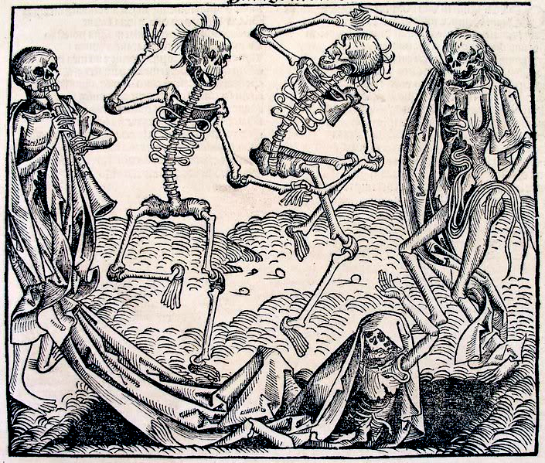

Danse Macabre images served several purposes, including:
- to help people express and share their grief;
- to remind each other that death is not only inevitable, but also the great equalizer, claiming the high and mighty as well as the humble;
When vulnerable mortals could depict, narrate, and enact the Dance of Death, they gained a subtle sense of control.

Monasteries and the clergy
In medieval times, monasteries played an important role in treating the sick. With the onset of the plague, there was a high death rate amongst monks that led to a severe shortage of the clergy. During the years of the Black Death, there was often neither the time nor the people to carry out the rituals followed with the dead and dying. About 40% of the priests died. Others ran away. There was no one to hear someone’s final confession of their sins, and no one to ring the death bell or conduct a proper religious service and funeral. Anger against the Church’s failure led some people to support other groups that they thought were more effective.
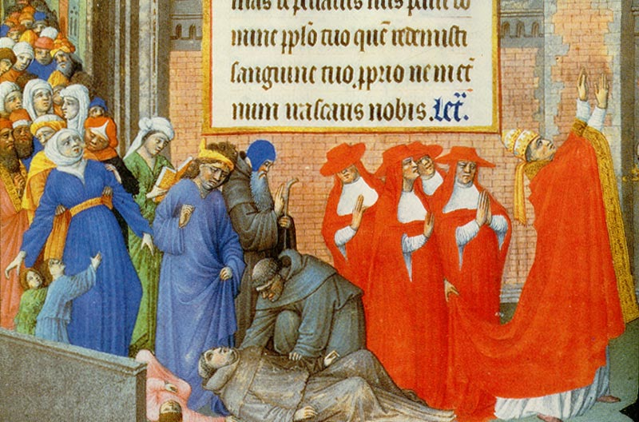

What do you think is happening in the scene above?
___________________________________________________________________________________________________________________________________________________________________________________________________________________________________________________________________________________________________________________________________________________________________________________________________________________________________________________

The Flagellants
The Flagellants were the most famous group hoping to please God and avoid the plague. They travelled from town to town for thirty-three and a third days (each day representing a year of Christ’s time on Earth). During their journey they whipped themselves with strips of leather tipped with iron spikes. At times, they even claimed to have miraculously cured people. It is more likely that they were helping spread the plague. The Pope eventually banned the movement and many Flagellants were executed.
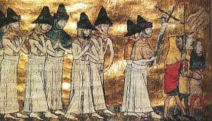

Finding Scapegoats
Fear, a sense of helplessness and sometimes religious fanaticism caused some people to turn against anyone who seemed in any way unusual. Jews, lepers and people though to practise witchcraft were all potential victims of those wanting to blame others for a disease they could neither understand nor cure.
Jews
In some areas of Europe, communities believed rumours that Jews poisoned local wells so that they could cause a plague that would destroy the power of the Catholic Church. People:
- Attacked Jewish homes and properties.
- Forced Hews to leave towns and cities
- Arrested and tortured Jews to gin their ‘confessions’
- Rounded them up and massacred them.
By the early 1350s, there had been more than 300 massacres of Jews, usually in cases where local mobs took control away from local authorities. One of the worst of these occurred in Strasbourg in 1349, when a mob murdered 2000 Jews. Many of the Jews who escaped this treatment left Western Europe and re-established themselves in Eastern Europe.
Other victims
People’s fears made lepers another easy target. People thought their skin disease was a sign that they were evil. They responded by killing lepers just as they killed Jews. In the Islamic world, some leaders interpreted the plague as Allah’s punishment for women sins. As a result, the sultan of Cairo denied women permission to leave their homes.
Increased government control
Governments tried, and largely failed, to control food supplies (made more difficult by shortages in labour) and the prices people paid for them. They did this by:
- Banning food exports
- Banning large-scale fishing
- Controlling grain prices
- Trying to prevent people selling foods for huge profits.
Questions:
- Which of the different responses to the plague would you judge to be:
- Helpful
- Illogical
- Of limited value
Give reasons for your answers.
- Identify the responses to the plague shown in sources 1 and 2.

Source 3 – an extract describing the treatment of Jews during the plague years.
Led by the Flagellants, and supported by everybody who was in debt to the Jewish moneylenders, pogroms (organised killings) took place all over Europe, particularly in Germany. In Hamburg, the Jews’ houses were bricked up and the families inside were forced to climb into wine casks, which were nailed up and thrown in the river. The citizens of Basle locked Jews in a wooden building on an island in the river and burned them to death.
From John Clare, I Was There: Medieval Towns, Bodley Head, London 1992.
- Identify evidence that source 3 provides us about:
- The treatment of Jews during the plague years
- The reasons people turned against them at this time.

